# CHAPTER 4: ADMINISTRATION VIA SCRIPTS

## Theory

WebSphere Application Server provides several command line tools for you to stop, start, and check status of application server processes or nodes. Those command line tools can run only local servers and nodes. They are located under ‘bin’ directory of application server or deployment manager profiles.

While using command line tools, you have to keep in mind that all names of application servers, nodes, or cells are case sensitive. If you fail to supply proper name, scripts will fail.

You should be also careful with running those scripts with proper rights. If you have installed Websphere as administrator on Microsoft operating systems, you have to run some of the commands as administrator.

You cannot run command line tools on a remote server. In order to manage servers remotely, you can use “wsadmin” scripting that connects to deployment manager using SOAP port.

“wsadmin” scripting also allows you to automate repeating tasks more easily and consistently. It gives you a full range of administrative activities.

The wsadmin tool has 5 objects available:

* AdminApp contains set of commands to manage installation, removal and editing of the applications.
* AdminConfig contains set of commands to create, remove and modify the elements of WebSphere Application Server.
* AdminControl contains commands that are used for operational control of the objects within the configurations such as start or stop an application server.
* AdminTask has a set of commands that are used for more administration specific tasks such as creating an application server or creating a cluster. Most of the things you can do with AdminTask commands can be done by using other objects, but they will take more lines to perform same thing.
* Help object provides help for each command and object or for the methods, attributes and notifications of MBeans.

The wsadmin tool can work both on local and remote systems. On local mode, you can even work when the application server is down where on remote mode, you have to have the application server up and running. On the other hand, local mode can have issues due to multiple access triggered synchronization of changes.

The wsadmin tool supports Jacl and Jython scripting languages. Although Jacl is the default language for wsadmin, you can change it by giving “-lang jython” parameter or editing the “wsadmin.properties” file under the properties folder of the given profile.

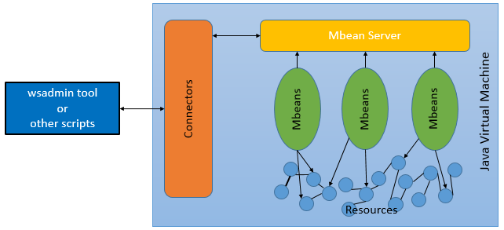

Jacl is a Tcl implementation written in Java and works on Java Virtual Machine. It can also enable communication between Java and Tcl interpreters and that allows you to use scripting functionality in to an existing Java applications.

Jython is a Pyhton programming language implementation written in Java. Jython uses both Pyhton modules and Java classes. You can also import and use any Java class. Jython compiles Python source code to Java bytecodes either on demand or statically.

## AIM

The aim of the lab exercise is to perform fundamental administrative operations such as stop, start an application server, a node agent and a deployment manager. You will be able to perform those using built-in command line tools and also with Jacl and Jython scripts.

In order to achieve this goal, you will need to perform following tasks:

* SOAP Configuration
* Stop & Start Application Server
* Stop & Start Node Agent
* Stop & Start Deployment Manager
* wsadmin scripting with Jacl
* wsadmin scripting with Jython

# Lab Exercise 4: ADMINISTRATION VIA SCRIPTS

|  |
| --- |
| SOAP Config.  Stop App Srv.  Stop Node Ag.  Stop DMGR  wsadmin JACL  wsadmin JYTHON |

## SOAP Configuration

## Stop & Start Application Server

## Stop & Start Node Agent

## Stop & Start Deployment Manager

## wsadmin scripting with Jacl

## wsadmin scripting with Jython

**Task 1: SOAP Configuration**This task is only required if you have enabled “Global security” in the previous chapter. The username used below is the one assigned as administrative user defined in the 2nd Lab Exercise, in task 2, “Secure Administration Console”.   
  
This task will save use to type each time the username and password we used administrative commands. We will store the administrative username and password in “soap.client.props” file for each profile and then we will encrypt the password to mitigate security considerations.

SOAP Config.

Stop  
App Srv.

Stop Node Ag.

Stop DMGR

wsadmin JACL

wsadmin JYTHON



**Step 1:** Change directory to deployment manager profile properties folder (Install_path/IBM/WebSphere/AppServer/profiles/Dmgr01/properties) and open the file “**soap.client.props**” to edit.

**Step 2:** Update the file with administrative user credentials into the fields “com.ibm.SOAP.loginUserid” and “com.ibm.SOAP.loginPassword”, then save the file and exit.



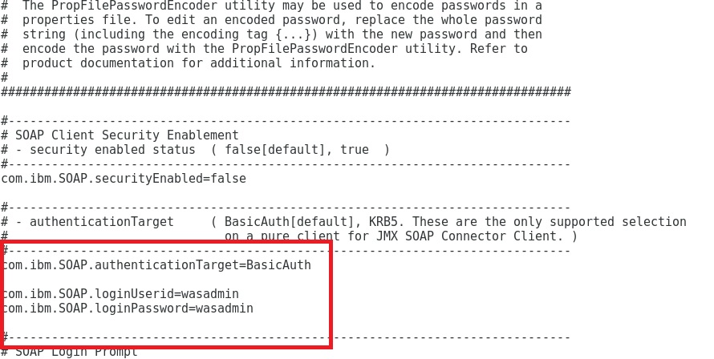

**Step 3:** Encode the “**soap.client.props**” file by using the following command. Change directory to the bin directory of the profile and run  
*“PropFilePasswordEncoder.sh /opt/IBM/WebSphere/AppServer/profiles/Dmgr01/properties/soap.client.props com.ibm.SOAP.loginPassword”*

SOAP Config.

Stop  
App Srv.

Stop Node Ag.

Stop DMGR

wsadmin JACL

wsadmin JYTHON



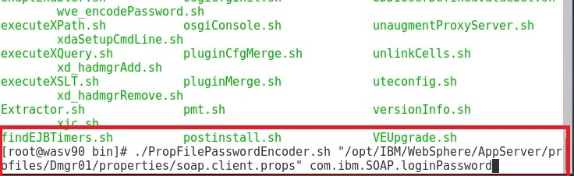

**Step 4:** Check the “**soap.client.props**” if the password field is encrypted.

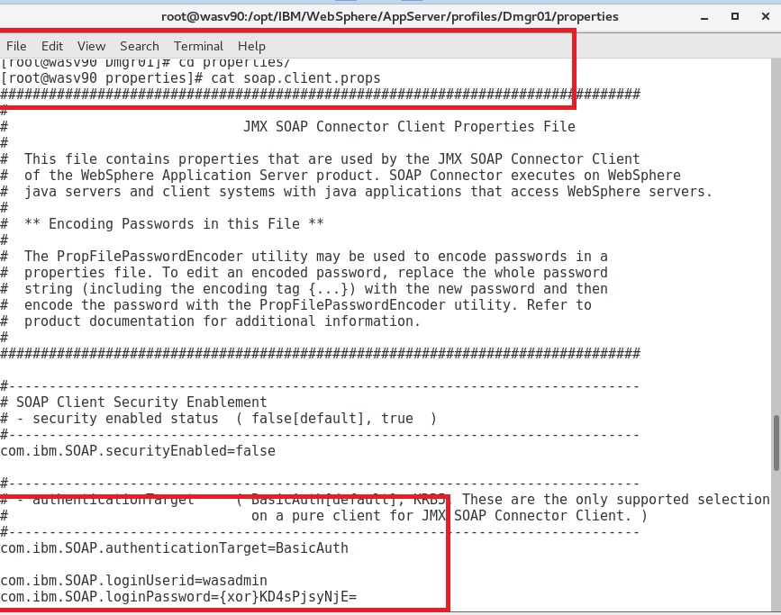

**Step 5:** Repeat the same steps for the “AppSrv01” profile.

SOAP Config.

Stop  
App Srv.

Stop Node Ag.

Stop DMGR

wsadmin JACL

wsadmin JYTHON



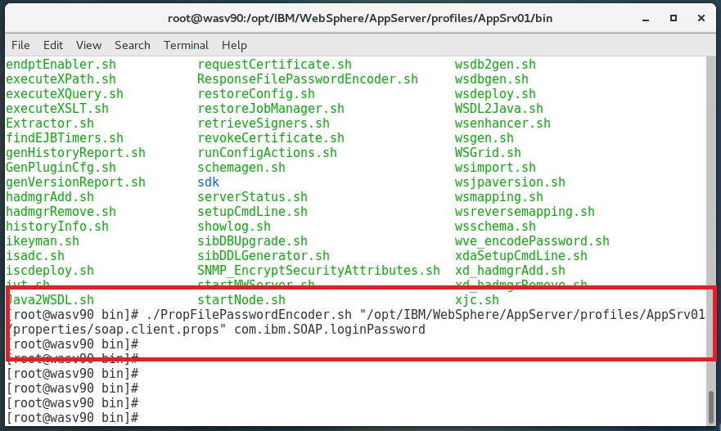

**Step 6:** Make sure that the password is encrypted.

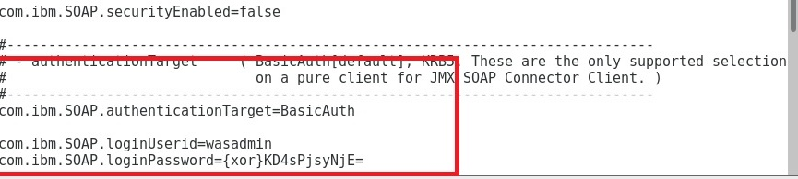

**Task 1 is complete!**

**Task 2: Stop & Start Application Server**

SOAP Config.

Stop  
App Srv.

Stop Node Ag.

Stop DMGR

wsadmin JACL

wsadmin JYTHON



**Step 1:** To stop the application server, change directory to the “bin” directory of the profile that server runs and issue command “**stopServer.bat server_name**”.

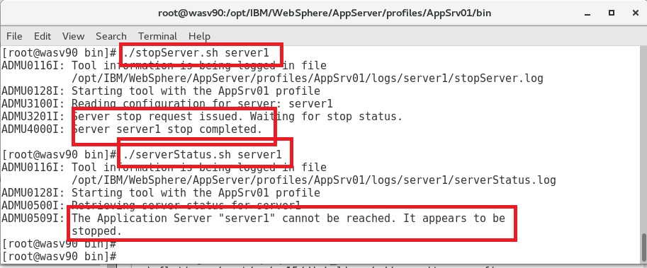

**Step 2:** For starting, run “**startServer.bat server_name**”. You can check the status of the server via “**serverStatus.bat server_name**”.

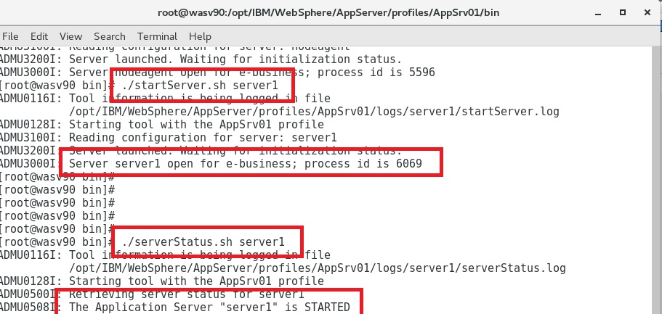

**Task 2 is complete!**  
**Task 3: Stop & Start Node Agent**  
**Step 1:** In order to stop the node agent, please issue the command “**stopNode.bat**”.

SOAP Config.

Stop  
App Srv.

Stop Node Ag.

Stop DMGR

wsadmin JACL

wsadmin JYTHON



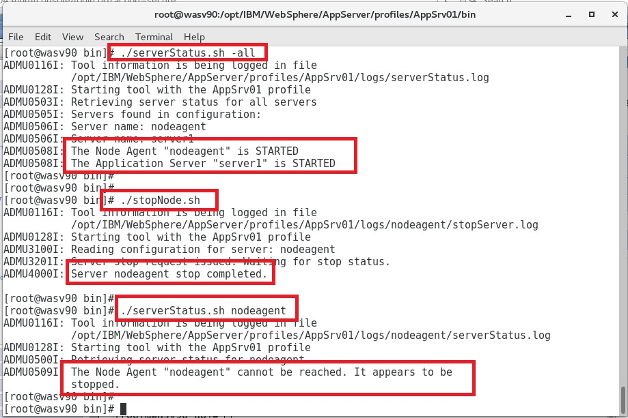

**Step 2:** Run “**startNode.bat**” to start the node agent.

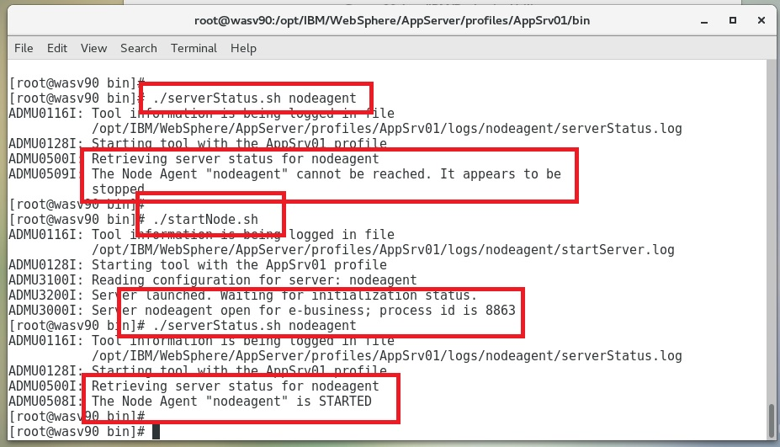

**Task 3 is complete!**

**Task 4: Stop & Start Deployment Manager**  
**Step 1:** Change directory to the “bin” directory of the deployment manager and run “**stopManager.bat**” to stop.

SOAP Config.

Stop  
App Srv.

Stop Node Ag.

Stop DMGR

wsadmin JACL

wsadmin JYTHON



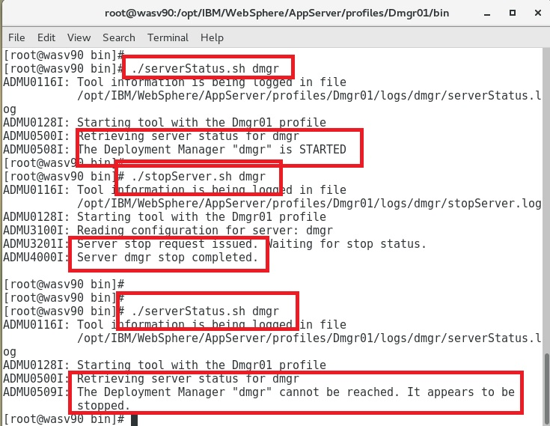

**Step 2:** Run “startManager.sh” to start deployment manager. You can always run “serverStatus.bat dmgr” to check the status of deployment manager.

SOAP Config.

Stop  
App Srv.

Stop Node Ag.

Stop DMGR

wsadmin JACL

wsadmin JYTHON



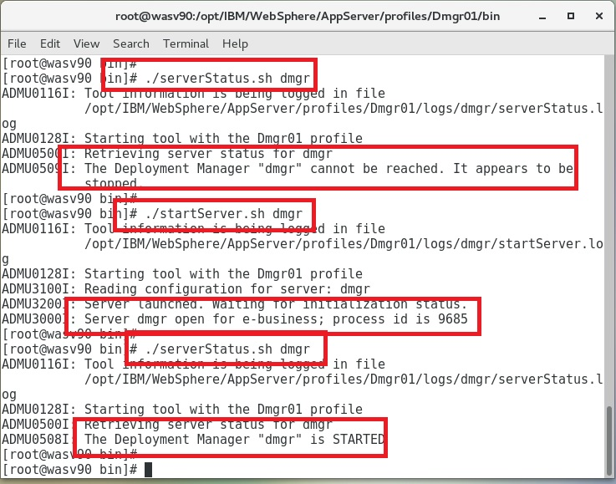

**Task 4 is complete!**

**Task 6: “wsadmin” Scripting with Jacl**  
**Step 1:** Change directory to “/opt/IBM/WebSphere/AppServer/profiles/Dmgr01/bin” run the command “**wsadmin.sh**”.   
  
“**$Help help**” command will show you the basic help information.

SOAP Config.

Stop  
App Srv.

Stop Node Ag.

Stop DMGR

wsadmin JACL

wsadmin JYTHON



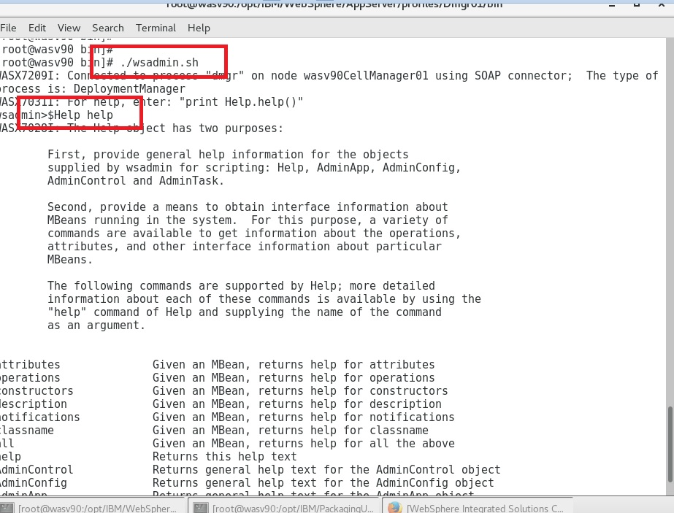

**Step 2:** Run the command “**$AdminConfig list Cell**” to list all the cells. When you get the list of the cells, run “**$AdminConfig showAttribute *cell_id* name**” where *cell_id*  is the output of previous command, to get the name of the cell.

SOAP Config.

Stop  
App Srv.

Stop Node Ag.

Stop DMGR

wsadmin JACL

wsadmin JYTHON



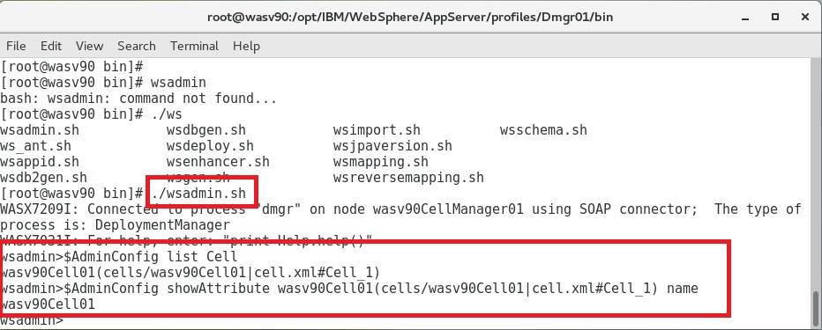

**Step 3:** Run “**$AdminConfig list Node *cell_id***” to list all the nodes under the cell provided.   
“**$AdminConfig showAttribute *node_id* name**” will give you the name of the node. *node_id* can be gathered from the previous command.

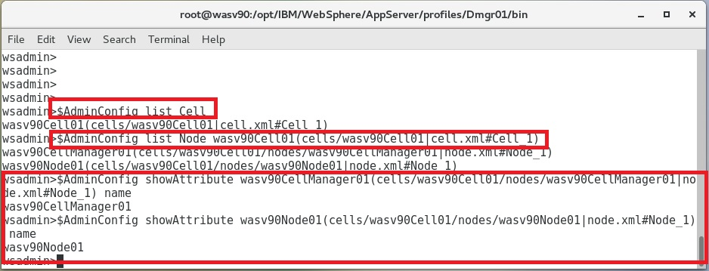

**Step 4:** In order to stop an application server, please issue the following command:

SOAP Config.

Stop  
App Srv.

Stop Node Ag.

Stop DMGR

wsadmin JACL

wsadmin JYTHON



“**$AdminControl stopServer *server_name* *node_name***”

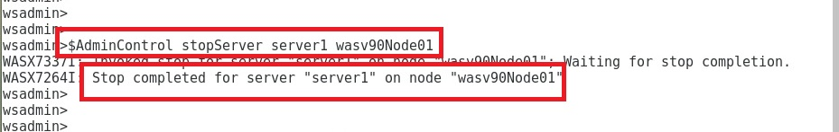

**Step 5:** Run “**$AdminControl startServer *server_name* *node_name***” to start an application server.

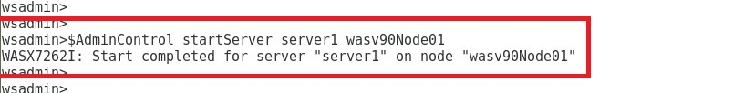

**Step 6:** In order to stop a node agent, please issue following 2 commands in “wsadmin” environment:  
“set node_agent_name [$AdminControl queryNames type=NodeAgent,node=*node_name*,*]”  
“$AdminControl invoke $node_agent_name stopNode”

SOAP Config.

Stop  
App Srv.

Stop Node Ag.

Stop DMGR

wsadmin JACL

wsadmin JYTHON



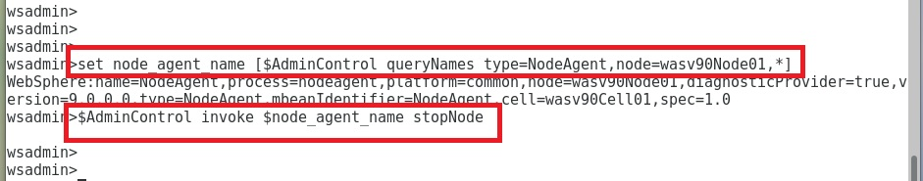

**Step 7:** Run following commands to check the status of an application server.  
“set server_name [$AdminControl completeObjectName cell=*cell_name*, node=*node_name*, name=*server_name*, type=Server,*]”  
“$AdminControl getAttribute $server_name state”

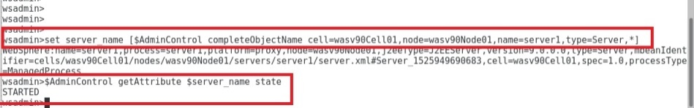  
  
**Task 5 is complete!**

SOAP Config.

Stop  
App Srv.

Stop Node Ag.

Stop DMGR

wsadmin JACL

wsadmin JYTHON



**Task 6: “wsadmin” Scripting with Jython**  
**Step 1:** Download “wsadminlib.py.zip” from   
<http://public.dhe.ibm.com/software/dw/wes/samplescripts/wsadminlib.py.zip> and  
“unzip wsadminlib.py.zip” to /opt/IBM/WebSphere/AppSrv/bin and then run “wsadmin”.

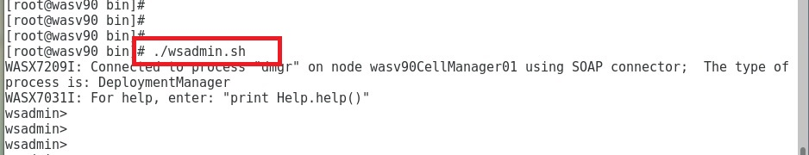

SOAP Config.

Stop  
App Srv.

Stop Node Ag.

Stop DMGR

wsadmin JACL

wsadmin JYTHON



**Step 2:** Issue command “**execfile(‘wsadminlib.py’)**” to load the file.

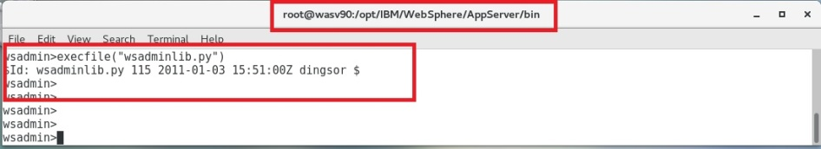

**Step 3:** Issue command “whatEnv()” to see your installation whether stand-alone or Network Deployment.

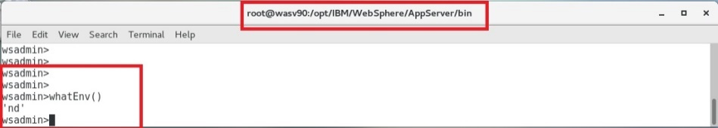

SOAP Config.

Stop  
App Srv.

Stop Node Ag.

Stop DMGR

wsadmin JACL

wsadmin JYTHON



**Step 4:** “getCellName()” will give you the name of your cell.

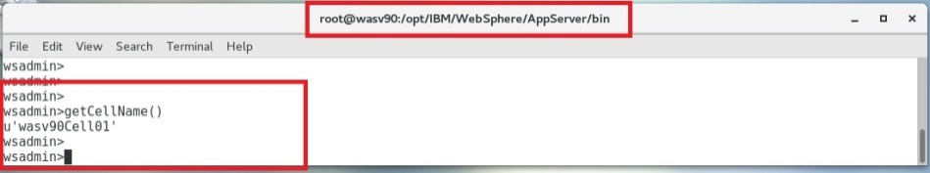

**Step 5:** “listNodes()” will list all the nodes except for deployment manager node and to see that run “getDmgrNodeName()” command.

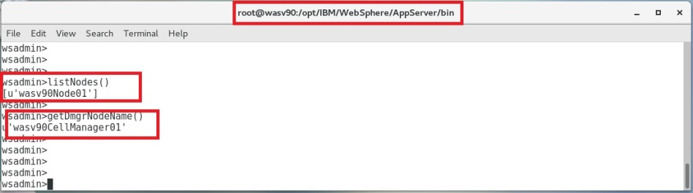

SOAP Config.

Stop  
App Srv.

Stop Node Ag.

Stop DMGR

wsadmin JACL

wsadmin JYTHON



**Step 6:** “listAllServers()” command will list all application servers.

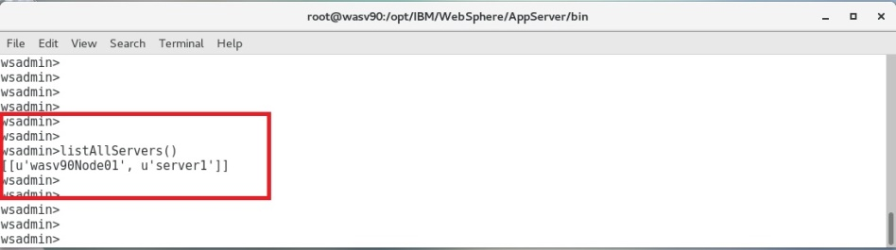

**Step 7:** To stop an application server, “stopServer(“*node_name”,”server_name”*)”.

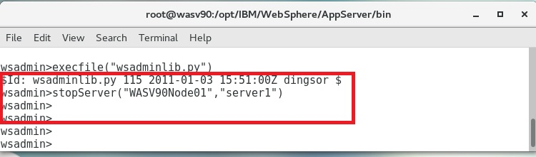

SOAP Config.

Stop  
App Srv.

Stop Node Ag.

Stop DMGR

wsadmin JACL

wsadmin JYTHON



**Step 8:** “startServer(‘*node_name’,’server_name’*)” will start an application server.

  
 **Step 9:** It is also possible to create our own python scripts using the existing ones. Create a file named “wsadmin_restart_server.py” and add following lines to the file.  
  
execfile(‘./wsadminlib.py’)  
enableDebugMessages()  
  
servername = ‘server1’ #change with your server name  
nodename = ‘WASV90Node01’ #change with your node name  
  
#Stop Server server1  
stopServer(nodename, servername)

#Start Server server1  
startServer(nodename,servername)

SOAP Config.

Stop  
App Srv.

Stop Node Ag.

Stop DMGR

wsadmin JACL

wsadmin JYTHON



Run the following command to restart the configured application server.

“execfile(“wsadmin_restart_server.py”)”

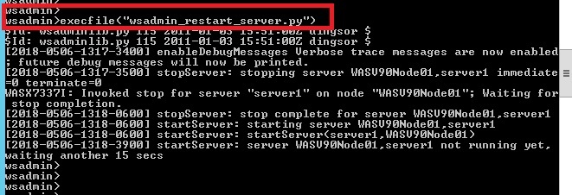

# SUMMARY

WebSphere Applications Server provides you to use several options to perform administration. There are already built in command line tools that gives you the possibility to perform operations such as stop, start, add, remove an application server, node, and cell and so on. It is also possible to use scripting for administration purposes. For that, you can use either Jacl or Jython using ‘wsadmin’ tool. It is both possible to send commands one by one through ‘wsadmin’ tool and feeding files of scripts to ‘wsadmin’ tool. Scripting allows you to manage Websphere remotely.

# REFERENCES

* http://en.wikipedia.org/wiki/Wsadmin
* http://www.ibm.com/developerworks/websphere/library/samples/SampleScripts.html
* http://pic.dhe.ibm.com/infocenter/wasinfo/v7r0/index.jsp?topic=%2Fcom.ibm.websphere.nd.multiplatform.doc%2Finfo%2Fae%2Fae%2Fcxml_javamanagementx.html

# INDEX

Jacl 97

Jython 97

wsadmin 96, 97